APPLICATION TO BE FEATURED AS ARTIST OF THE MONTH

DETAILS
Name
Address
Phone:
Mobile phone:
Email:
Facebook page:
Website:
Date of Application
The Medium used / description of art form:
Please attach a current CV of yourself and recent works and send to the AoM coordinator at this email: aom@gmail.com
For publicity, we would like permission to take and use photos appropriately:
Please read and sign the following Agreement:

I have read the Description of our Featured Artist of the Month Program (attached) and agree to the Conditions as stated there.

Yes, I give permission for photos to be taken & used:
Yes, I understand if any pieces sell while on display there will be a commission of 28% payable to the BICAS.

Signed: ___________________________________ Date: _______________
Print Name: ____________________________________
This page to be returned to the Bribie Island Community Arts Centre
To apply for ‘ARTIST OF THE MONTH’, please complete the relevant form and forward to:
MAIL:
The Secretary - BICAS,
For attention – Venue Manager
PO Box 71
Bribie Island 4507
EMAIL:

Scan and send to
AOM@gmail.com

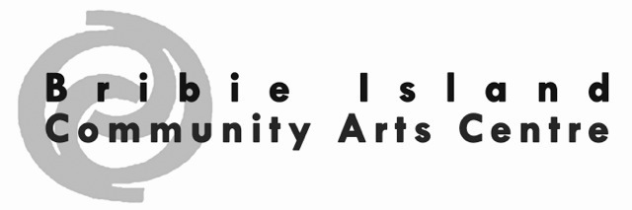
ARTIST OF THE MONTH PROGRAM
The date for hanging/displaying your works is the first day of the month and pack down is the last day of the month.
Bribie Community Arts Centre will:
- Provide 4.5m x 1.8m of hanging space complete with a hanging system.
  - (Should you have 3D work, we will negotiate a display area with the Display committee, with shelves/plinths etc.)
- Provide space and time for a morning tea for you to host and is part of the agreement. It is held from 10.30am on the SECOND Friday of the month, where you, the artist, invite people you feel would like to see what you do. This is an opportunity for you to market and showcase your artworks and yourself.
- Advertise in our local papers and possibly gain editorial space. Please include suitable information for this.
- Charge a 28% commission on any works sold during the month while on display.
- Provide small Gallery cards for each piece on display at a cost of $0.50 each

The Artist of the Month will:
- Provide details and any photos for advertising and editorial use in the first week of the month PRIOR.
- Provide a list of all works, artist name, artwork name, selling price (including commission) at least TWO WEEKS prior for small Gallery signs to be made and for work to be barcoded.
- Bring in all pieces and hang/display (can assist if needed)
- Clearly label all pieces with name, description and selling price.
- Advise the Centre of proposed numbers coming to your morning tea (for set-up & catering purposes)
- Collect all artwork/pieces on the last day of the month.

From January 2020, an administration fee of *$80 for BICAS members and $100 for Non-Members will be charged for Artist of the Month participants. A deposit of $20 will be required with this application and the balance to be paid one month before the start of your month of AoM exhibition.
*may be subjected to cancellation fee

BICAS Bank details:
Direct Bank Transfer, Bribie Island Community Arts Society Inc. BSB:084 745 Acc.:155431921 Reference AoM INITIAL.SURNAME
Payment Options MAIL TO Artist of the Month payment BICAS PO Box 71 Bribie Island, QLD 4507 CHEQUE/MONEY ORDER payable to Bribie Island Community Arts Society Inc.
CREDIT CARD Charge my Mastercard Visa (Please circle) CVV___________for the Amount of $______________ __
CARD NUMBER _ _ _ _ _ _ _ _ _ _ _ _ _ _ _ _ Expiry Date _ _ _ _ Signature __________________________________

