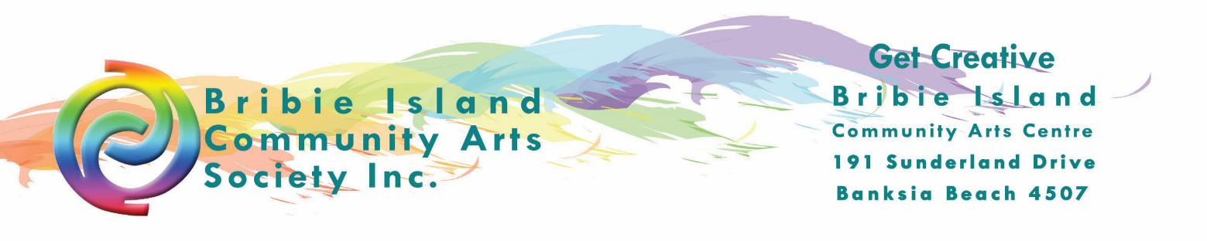

Expression of Interest in being part of the SEASONED GALLERY’S Spring Collection

Name
Address
Telephone
Mobile
Email

Description of artworks. (Max 100 words)

Description of works to be exhibited. Please give details.
Medium:
Size:
Number of works (approx):
Method of presentation (e.g. wall mount, tree, shrubbery, stump etc):
Price range (allowing for commission) :

Season you are interested in:
- SPRING 1 October 2020
- SUMMER 1 December 2020
- AUTUMN 1 March 2021
- WINTER 1 June 2021

Please ensure the following documentation is attached to this completed application form
- Digital images of recent or indicative work. Images should be digital (jpeg on disk or memory stick or emailed with size no larger than 1mb per image).
- 2 images per individual.
1 image per artist if it is a group submission.
- CV of the artist.

Have you read Gallery Hire Terms and Conditions? Yes / No.
Have you exhibited at The Arts Centre previously? Yes / No. If Yes, what year/s _______________

For enquiries regarding exhibition, Expressions of Interest and The Arts Centre exhibition program please contact:

Gallery Curator, Bribie Island Community Arts Centre Bribie Island
191 Sunderland Drive, Banksia Beach, Bribie Island QLD 4507
Tel: 07 3408 9288
﻿Email: info@bribieartscentre.com.au

