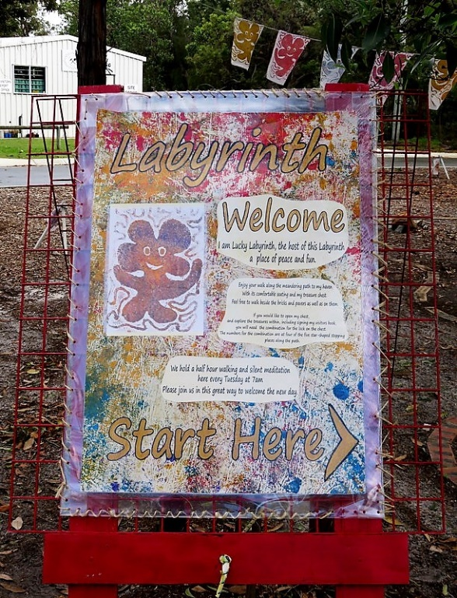
COME Paint Rocks*
in the Art Centre’s peaceful
Lucky’s Meandering Labyrinth
during BICAS 30th Anniversary week
December 10 – 14
Lucky’s Meandering Labyrinth is a special area in the banksia woodland outside the BICAS Courtyard towards the Gem Club to enjoy, explore and to find a peaceful spot to sit and rest. The Labyrinth has been specially decorated for the Celebrations, and will be open throughout the week for visitors to enjoy.
Each afternoon, at 2pm we will welcome you to the Labyrinth for a short silent walking meditation and a chance to explore the area with us. Bring an instrument if you have one. You’re also welcome to decorate rocks for the Labyrinth, talk and make spirit children.
We will hold our regular Tuesday meditation at 7 am, at which everyone is welcome to join to welcome the day in a special way..

*Rocks and painting materials supplied

30th Anniversary Rocks

Add to the Art Centre 30th Anniversary colour by decorating one of these rocks in commemoration of the occasion. Use the supplied textas and/or oil pastels, or your own art supplies, and be as elaborate or simple as you want – from just a word or your name to an elaborate design.

When you are finished, you can place your rock in the labyrinth area in the banksia woodland outside the BICAS Courtyard towards the Gem Club, or just leave it in this tray for others to enjoy.

